**7. Kubernetes Namespaces – Introduction**

--- **note** – we are going to understand about kubernetes name spaces on very high level.

**Namespaces – interdiction**

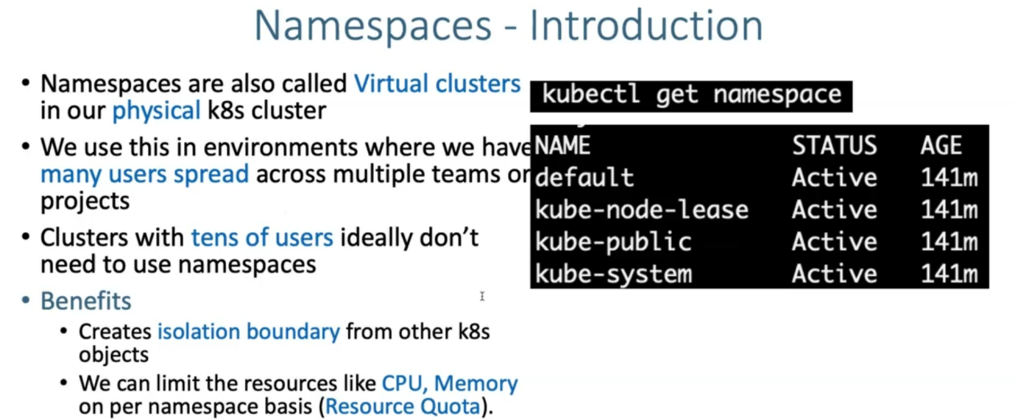

--- **default** – so far whatever we created, we created inside of default name space.

--- **kube-node-lease** – this name space is for lease object associated with each node which improves performance of the node. It will improve the performance of the kubernetes cluster.

--- **kube-public** – this name space is created automatically and can be readable by all users. Even unauthenticated users can read.

--- **note** – we don’t need to worry about **kube-node-lease** and **kube-public**.

--- **kube-system** – all the kubernetes system related objects are created in kube-system.

--- **kubectl get all --namespace kube-system** or **kubectl get all -n kube-system** – it will list all the resources which are present inside of this namespace.

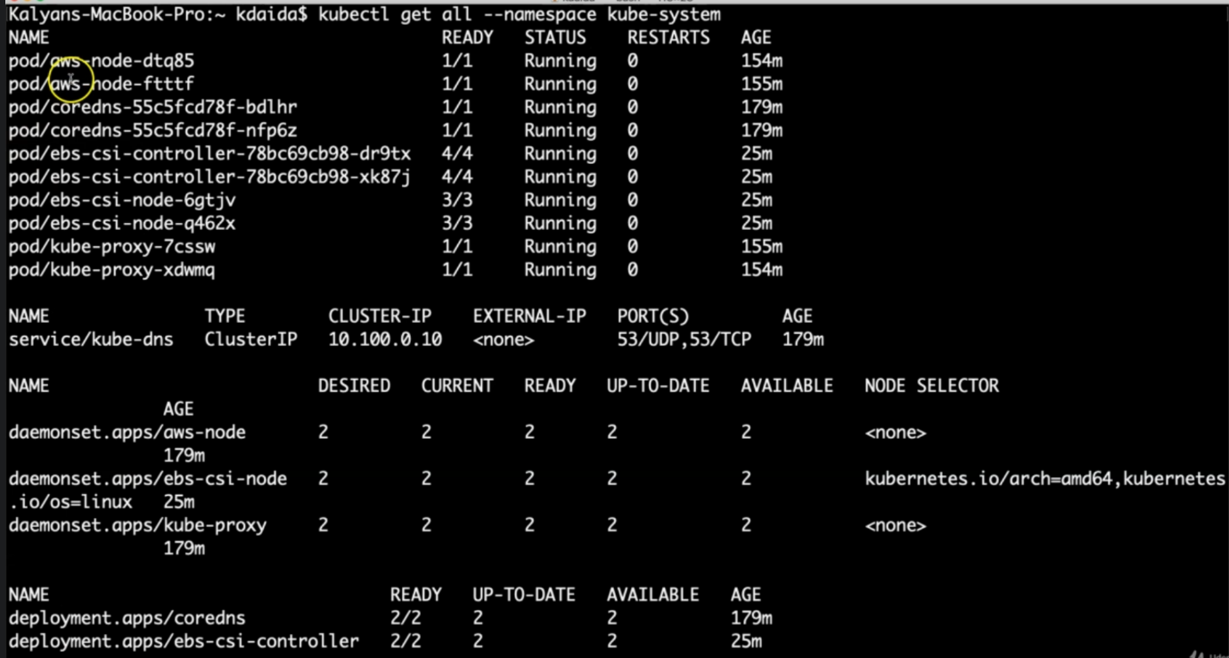

**Same objects creating in different namespaces**

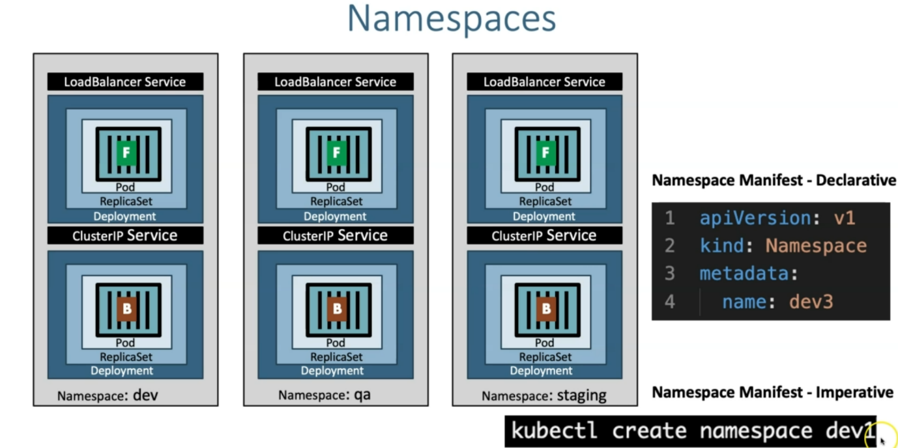

--- **note** – in the above diagram, we can see that we can create namespace using Declarative and imperative way.